Artificial intelligence project
“AI TRADER”

Bachelor in Technology
(Computer science and engineering)

SCHOOL OF CSE (LPU)
PHAGWARA

Name: DHANANJAY GUPTA
Reg no: K18GX
Roll no: B52
Section: K18GX (group 2)
Course code: INT404
Faculty: SAGAR PANDAY

LOVELY PROFESSIONAL UNIVERSITY
Phagwara (Punjab)
TABLE OF CONTENT

- Objective
- Project overview
- Code snippet
- Execution
- Results / predictions
- Future scope

OBJECTIVE

The objective of this project is to build a simple AI (“AI TRADER”) to analyse the previous data set in given time frame to derive the number of data points.
Using simple linear regression for the produced data point to predict the next data point value on a daily time frame.

Predicting how the stock market will perform is one of the most difficult things to do. There are so many factors involved in the prediction – physical factors vs. physiological, rational and irrational behavior, etc. All these aspects combine to make share prices volatile and very difficult to predict with a high degree of accuracy.
AI is shaping the future of stock trading. Using AI, robo-advisers analyze millions of data points and execute trades at the optimal price, analysts forecast markets with greater accuracy and trading firms efficiently mitigate risk to provide for higher returns.
“Artificial intelligence is to trading what fire was to the cavemen.” That’s how one industry player described the impact of a disruptive technology on a staid industry.”

PROJECT OVERVIEW
This ai program create data points for given time frame on provided past dataset.
Linear regression is used to analyse the data points to predict values for next data point on given time frame.

LINEAR REGRESSION
Linear regression is a linear approach to modeling the relationship between a scalar response (or dependent variable) and one or more explanatory variables (or independent variables). The case of one explanatory variable is called simple linear regression. For more than one explanatory variable, the process is called multiple linear regression. This term is distinct from multivariate linear regression, where multiple correlated dependent variables are predicted, rather than a single scalar variable.
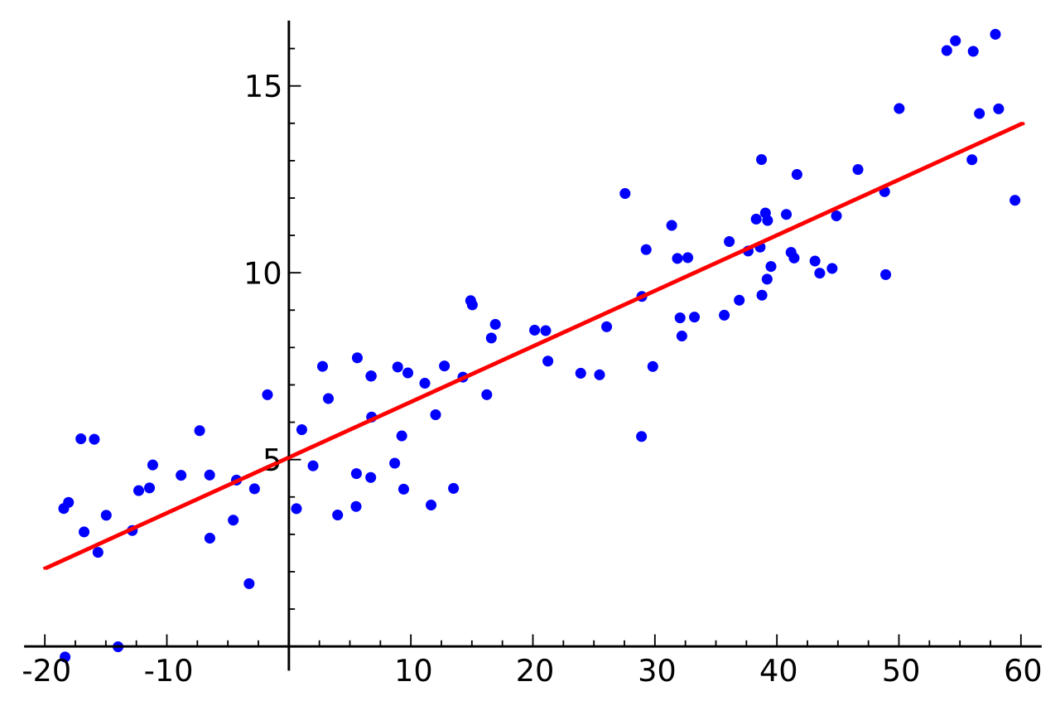

- Scikit-learn (for linear regression)
Scikit-learn is a free software machine learning library for the Python programming language. It features various classification, regression and clustering algorithms and is designed to interoperate with the Python numerical and scientific libraries NumPy and SciPy.
Installation: Pip install –U scikit-learn scipy matplotlib
- Yahoofinancial
Python module to get stock data from Yahoo! Finance.
Yahoo Finance provides access to more than five years of daily OHLC price data. Also, you can get minutes OHLC data for recent days.
To import historical data:
(yahoo_financials.get_historical_price_data("2010-1-10" ,"2019-1-10" ,"daily"))
Installation: Pip install yahoofinancials

CODE SNIPPET
import pandas as pd
import numpy as np
from sklearn.linear_model import LinearRegression
from yahoofinancials import YahooFinancials
import mpl_finance
import matplotlib.pyplot as plt

stock=input("stock name ?")
highs=[]
lows=[]
opens=[]
closes=[]

yahoo_financials= YahooFinancials(str(stock))
stats= (yahoo_financials.get_historical_price_data("2010-1-10" ,"2019-1-10" ,"daily"))

i=0
for date in stats[str(stock)]["prices"]:
if i==0:
i += 1
continue

highs.append(date["high"])
lows.append(date["low"])
opens.append(date["open"])
closes.append(date["close"])
i += 1

print("no. of data pts:",i)

total=[]
totalopens=[]
for j in range(4):
opens.append(0)

for i in range(i-1):
total.append=([opens[i], lows[i], highs[i], closes[i]])

def predictor(lst,months):
total_training = lst[0:i-months]
total_validation = lst[0:i-months]

df = pd.DataFrame(total_validation, dtype=float)
Xvalidation = dfp.iloc[:, :-1]
Yvalidation = dfp.iloc[:, :-1]

clf = LinerRegression
clf.fit(XTrain , YTrain)

print("\n\n")

dfp = pd.DataFrame(total_validation, dtype=float)
Xvalidation = dfp.iloc[:, :-1]
Yvalidation = dfp.iloc[:, :-1]

print("\n\n prediction")
YPrediction = clf.predict(Xvalidation)

print("\n original")
print(Yvalidation)

print("\n predicted")
print(YPrediction)

predictor(total,1)

EXECUTION
- “AI TRADER” uses some machine learning packages and data import api packages like scikit-learn and yahhofinancials. Before execution these packages need to install on system.

*package installation
import pandas as pd
import numpy as np
from sklearn.linear_model import LinearRegression
from yahoofinancials import YahooFinancials
import mpl_finance
import matplotlib.pyplot as plt

- Scikit-learn
To install scikit-learn, run the following code .
Pip install –U scikit-learn scipy matplotlib
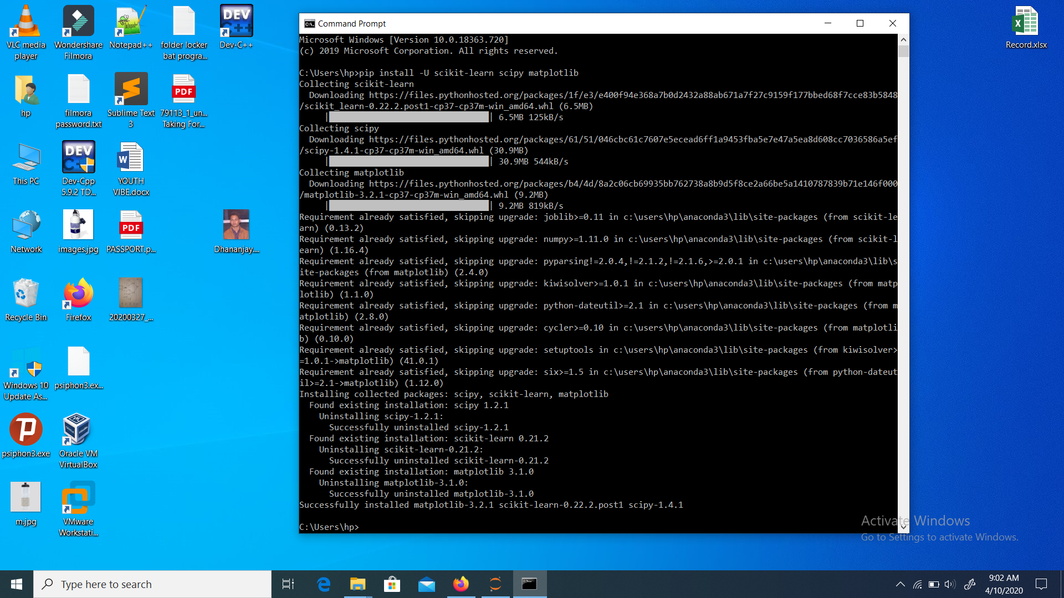

- yahoo financials
To install yahoofinancials, run the following code.
Pip install yahoofinancials 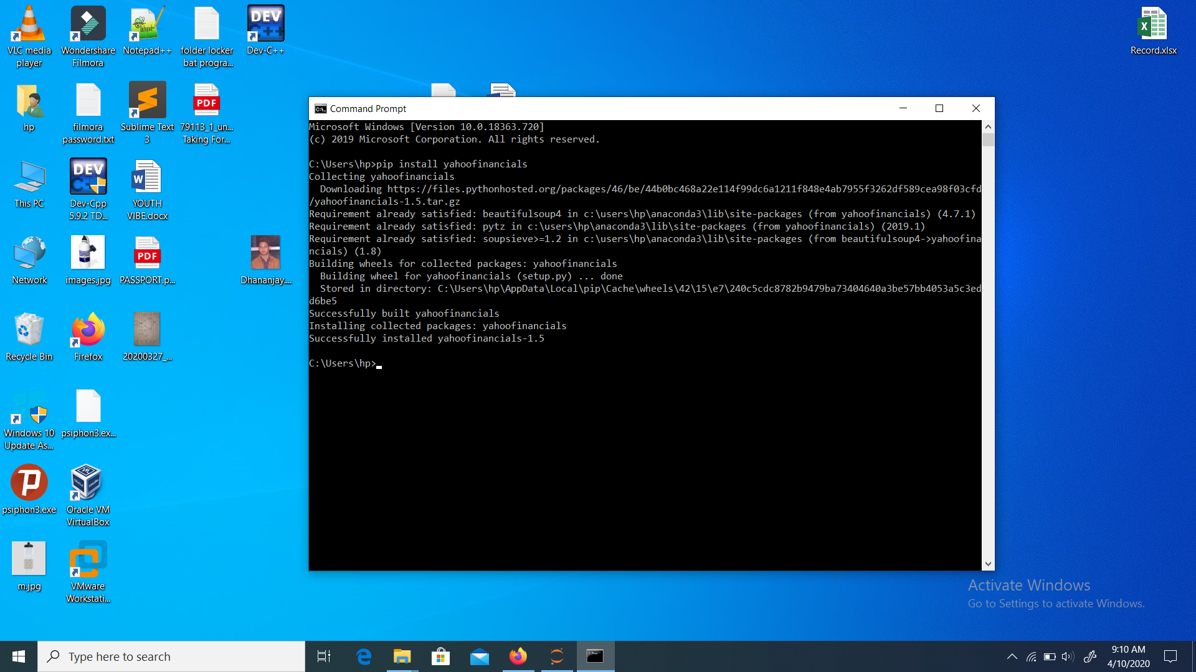

Most other packages are already installed on most of the platform, so u can directly import.

RESULT / PREDICTION
This ai program Analyses the no. of data points in the provided data frame with simple use of liner regression to produce a data point for next time frame.
*caution : the stock keyword should be exactly the same as listed on exchange.
For example: google(“GOOGL”) , facebook(“FB”)

- “GOOGL”
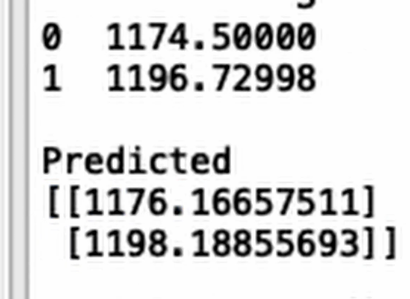

- “FB”
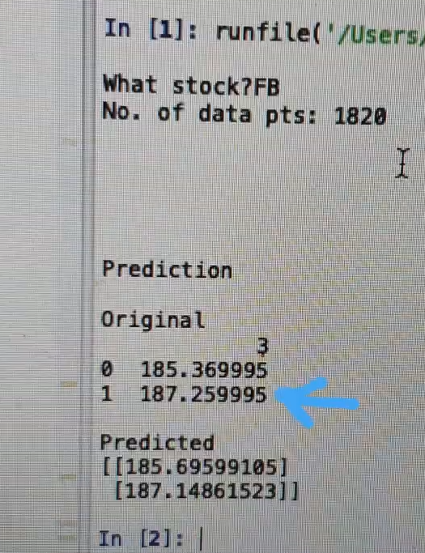

FUTURE SCOPE
Trading has certainly been the area of investing most directly disrupted by technology, and that disruption shows no signs of ebbing. A typical trading desk in a few years might not look much different than it does today but it will almost certainly function in a significantly smarter fashion for traders who will be expected to do more, as well.
With more and more professional trading desks adapting to technology to reduce human emotional interferences and limitations to increase efficiency and profitability, AI is emerging as an demanding technology to perform algorithm based trading.

